World Petanque Offline Cup 2020
In Cooperation with International Humanitarian Games Association (IHGA)

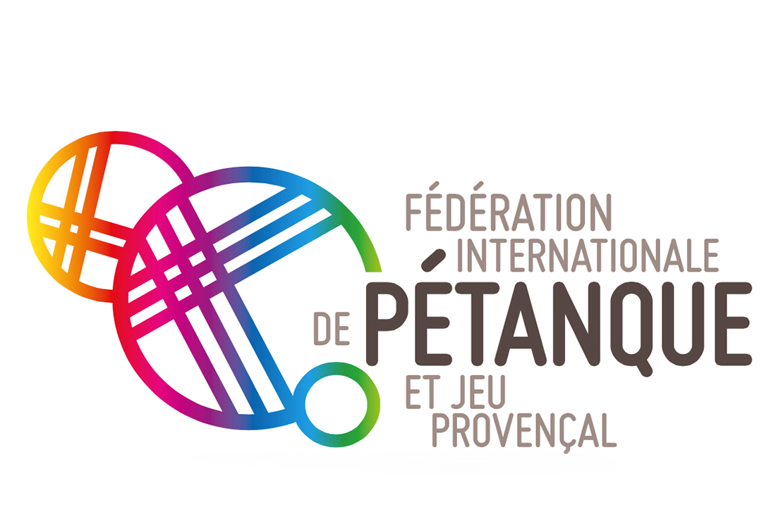

Are honored to proclaim herewith
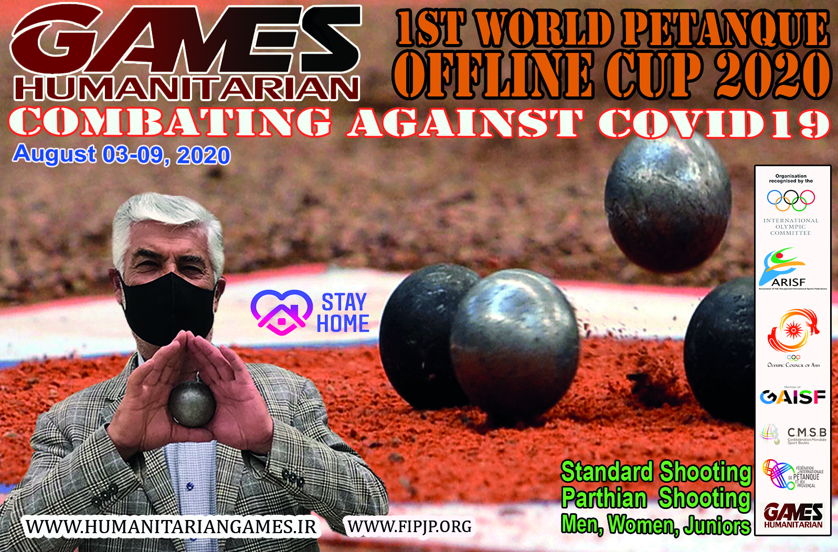
Standard Shooting (with some modifications)
Parthian Shooting (adrenaline producer style)

WORLD PETANQUE OFFLINE CUP 2020
Combating Against COVID19 – Humanitarian Games
August 03-09, 2020 – Offline Throughout the World

Details of the World Petanque Offline Cup 2020

- Invitation to all National Federation Affiliated in the FIPJP
- The Event Organizing Committee
- Organizers and Supporters
- Registration Deadline
- Event Schedule
- Requirements
- Method of Participation
- Individual Participation Application Form
- Awards

WORLD PETANQUE OFFLINE CUP 2020
Combating Against COVID19 – Humanitarian Games
August 03-09, 2020 – Offline Throughout the World

Invitation

To: The National Federations / Associations
Respecting President, Secretary General

Dear Sir/Madam

On behalf of organizing committee of WPOC 2020, I am pleased and honored to invite you to the 1st World Petanque Offline Cup – Combating Against COVID19 throughout the world, during the period of August 03-09, 2020.
As it is not predictable that when the COVID19 pandemic will end, organizing the named event will be a milestone for FIPJP to show its capacity for involving people in sport and competitions and not allow to give up anymore.
The WPOC in cooperation with the International Humanitarian Games Association will offer good opportunities to juniors & seniors to participate in different kind of Petanque competitions in order to show to all Olympic movement specifically the IOC that this pandemic cannot stop our organization. We will go through this by the offline shooting completions and motto of “Boules Sports Fans – Wash Your Hands”.

Please find the practical details of the championships hereunder.

Sincerely Yours,
On behalf of Organizing Committee
Chairman, Jasem Manouchehri, Ph.D.
petanque.humanitarian@gmail.com

WORLD PETANQUE OFFLINE CUP 2020
Combating Against COVID19 – Humanitarian Games
August 03-09, 2020 – Offline Throughout the World

Organizing Committee

Supreme Council:

Claude Azema, France (Supreme Authority of the International Petanque Federation)
Dr. Behrouz Karkhanei, Iran (IHGA)
Mohammad Ghasem Manouchehri, Iran (IHGA)
Bernard Aurouze, Canada (FIPJP)
Suphonnart Lamlert, Thailand (FIPJP)
Celine Peronnet, France (FIPJP)
Jean Luc Fuentes, Monaco (FIPJP)
Reinold Borre, Belgium (FIPJP)
Karel Dohnal, Czech Republic (FIPJP)
Claudio Mamino, Italy (FIPJP)
Stephane Pintus, Monaco (FIPJP)
Gerard Schneider, Luxemburg (FIPJP)

Chairman:

Dr. Jasem Manouchehri, Iran

Commissions:

Referee Commission: Chair - Reinold Borré (Belgium)
- Secretary – Ali Akbar Soltani (Iran)
- Member – Jean-Luc Fuentes (Monaco)
- Member - Marie-José Fournier (Canada)
- Member - Alex Chen (Chinese Taipei)
- Member – André Deramon (Australia)
- Member - Imed Bouzriba (Tunisiea
- Member - Narong Kitudom (Thailand)
- Member - Patrick Grignon ( France)

Technical Commission: Chair - Victor Nataf (France)
- Secretary – Nahid Rezvani (Iran)
- Member – Khan P(Thailand)

Education, Research & Development Commission: Chair - Claude Raluy (France)
- Secretary – Amin Ebrahimian (Iran)
- Member – Stéphane Pintus (Monaco)

Media Commission: Chair - Masoumeh Saeidian (Iran)
- Secretary – Claude Stirmel (France)

Communication Commission: Chair – Masoumeh Manouchehri (Iran)
- Secretary – Ali Akbar Shamiri (Iran)

WORLD PETANQUE OFFLINE CUP 2020
Combating Against COVID19 – Humanitarian Games
August 03-09, 2020 – Offline Throughout the World

Organizers and Supporters

a) FIPJP
b) 1st Offline Humanitarian Games – Recognized by the Iranian Red Crescent Society
c) Boules & Petanque Association of Iran
b) All National Federations Affiliated in FIPJP

WORLD PETANQUE OFFLINE CUP 2020
Combating Against COVID19 – Humanitarian Games
August 03-09, 2020 – Offline Throughout the World

Registration Deadline

a) Registration for Seniors (more than 18 years old at the first day of the competitions): July 10-20, 2020
b) Registration for Juniors Seniors (less than 18 years old at the first day of the competitions): July 10-20, 2020

Note: Registration must be accomplished by the national federations affiliated in the FIPJP through petanque.humanitarian@gmail.com

WORLD PETANQUE OFFLINE CUP 2020
Combating Against COVID19 – Humanitarian Games
August 03-09, 2020 – Offline Throughout the World

Event Schedule

a) Competitions for Seniors: August 03-09, 2020
b) Competitions for Juniors: August 03-09, 2020

No | Program | Date | Time
1 | Sending Movie File by Each Player | August 03rd | 08:00 – 16:00 GMT
2 | Preliminary Phase Judgement | August 04th to 05th | Whole Days
3 | Introducing Bests 8 Players in Each Style and Each Age and Gender Category by the Referee Commission | August 05th | 18:00 GMT
4 | Announcement of the Way of Competitions for the Final Phase to the Bests 8 Players | August 06th | 06:00 GMT
5 | Sending Movie by bests 8 Players | August 06th | 06:30 – 16:00 GMT
6 | Final Phase Judgement | August 07th | Whole Days
7 | Preparing Awards | August 08th | Whole Days
8 | Award Ceremony | August 09th | 14:00 GMT

WORLD PETANQUE OFFLINE CUP 2020
Combating Against COVID19 – Humanitarian Games
August 03-09, 2020 – Offline Throughout the World

Requirements

a) Shooting Circles (if available)
b) Shooting Boules and Jack
c) a simple cell phone with camera
d) email address and Telegram connection
e) suitable cloths and mask on the face

WORLD PETANQUE OFFLINE CUP 2020
Combating Against COVID19 – Humanitarian Games
August 03-09, 2020 – Offline Throughout the World

Method of Participation

Both A & B styles of shooting competitions will be judged in two phases. The first, as the preliminary phase, will be for all participants with the below rules. The second, as the final phase, will be for the bests 8 players of each shooting styles. For ensuring the high quality of the competitions and also fair in judgements, the rules of the final competitions will be explained at the same day of the final matches.

A) Modified Standard Shooting – Offline Competition Rules:
- It will be played in 3 rounds: Round 1 (one target boule – Figure 1), Round 3 (target boule between 2 “obstacle” boules – Figure 3) and Round 5 (target jack – Figure 5) of the Standard Shooting of the FIPJP.
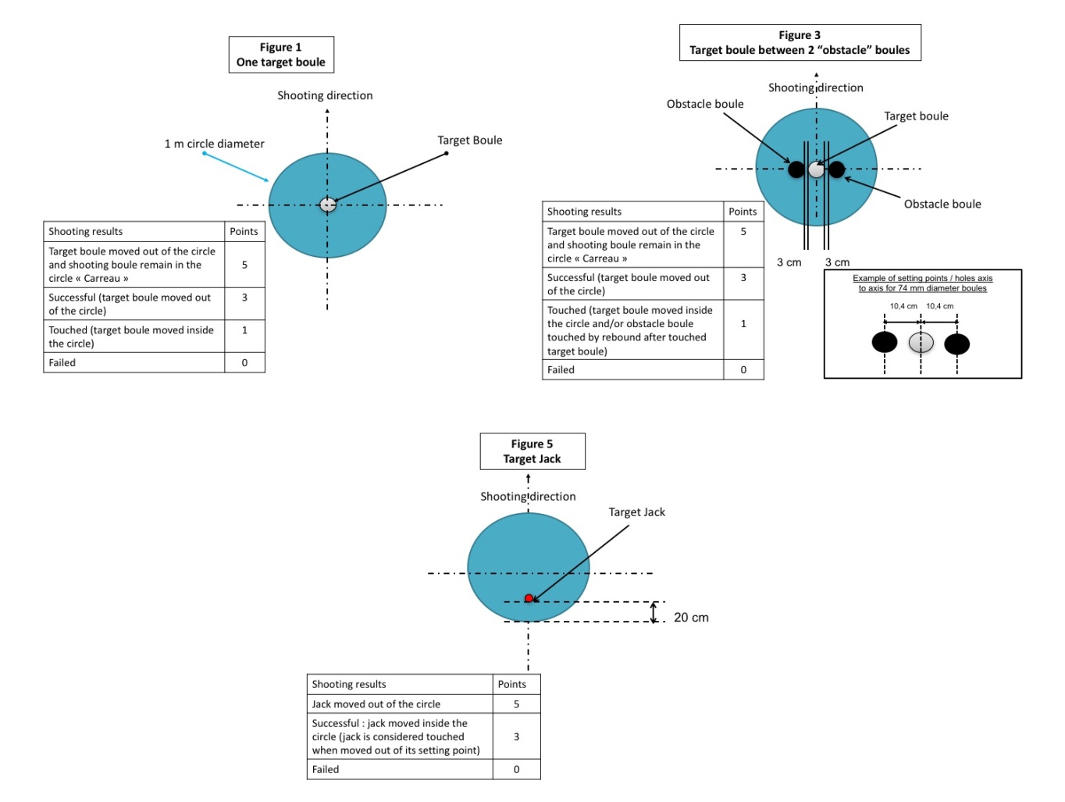

- The point for each shoot will count same as the rules of the standard shooting of the FIPJP (0 – 1 – 3 - 5).

WORLD PETANQUE OFFLINE CUP 2020
Combating Against COVID19 – Humanitarian Games
August 03-09, 2020 – Offline Throughout the World

- For each round there will JUST TWO SHOOTS and there will be JUST SIX SHOOTS in total. The first in each round will be from the distance of 8.5 meters and the second from 9.5 meters (Figure A).
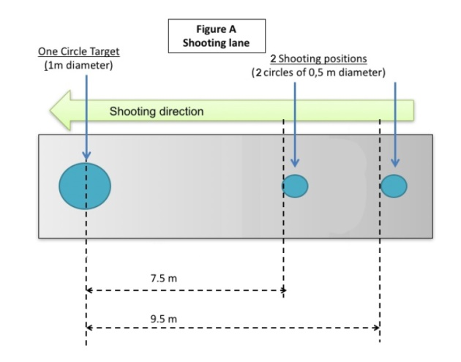
- Validity and value of each shoot will be as same as the FIPJP rules.
- Circles for all target and shooting position can be draw on the ground by a simple color spray (in case not access to spray, it is acceptable to draw it by foot on the sand in clear and visible way).
- Boules, jack and their color, size and weight must be standard.
- All participants MUST HAVE a mask on their face during the shootings (not at the time of speaking in front of camera).
- All participants have to use a camera (high quality cellphone is acceptable) in a FIXED PLACE watching exactly on the target boules or jack in a way that WHOLE BODY of the player is visible in the movie.
- The movie MUST BE recorded horizontally and in full HD (1080) format.
- After each shoot, the player has to replace the moved targets in a right way himself/herself.
- At the beginning of the recording (before first shoot), the player must be at the front of the camera, and says JUST THIS WORDS: My name is ………. From the country of ……………, BOULES SPORTS FANS – WASH YOUR HANDS.
- The recorded movie MUST BE totally less than 03:59 minutes (239 seconds).
- There MUST BE NO ANY CUT OFF during the movie from beginning to the end. It must be clear to all referees.
- The points counting will be as below table:
Item | Point
Round One (0-1-3-5) | Maximum 10
Round Two (0-1-3-5) | Maximum 10
Round Three (0-3-5) | Maximum 10
Disciplines for the wore Cloths, Mask and used equipment | Maximum 2
Quality of the movie | Maximum 2
Ability to finished all in 239 sec | Maximum 1
Total | Maximum 35

WORLD PETANQUE OFFLINE CUP 2020
Combating Against COVID19 – Humanitarian Games
August 03-09, 2020 – Offline Throughout the World

B) Parthian Shooting – Offline Competition Rules:
The idea of this method of shooting came from Iran in which there is no limitation for shooting a boule. It has several decades of tradition for playing in this country called Parthian (as an obstacle combat-precision sport), however, you may see it in similar way in social media performed by many players around the world.
In this style of shooting, a player may put a target boule on ground, a rock, a tree, side of a river, hanging by a rope, moving on a surface, or any other innovative obstacle or way that make an extreme and adrenaline producer shooting. There are some sample videos available in this video link: https://www.youtube.com/watch?v=Ep8ZzoD1elw. This is as fun but can be competitive with the following rules:
- It will be played in 1 round and 1 shoot.
- The distance of the player and target boule must be at least 8 meters. There is no limitation to do it in a longer distance.
- All participants MUST HAVE a mask on their face during the shooting (not at the time of speaking in front of camera).
- All participants have to use a camera (high quality cellphone is acceptable) in a FIXED PLACE watching exactly on the target boules in a way that WHOLE BODY of the player is visible in the movie.
- The movie MUST BE recorded horizontally and in full HD (1080) format.
- At the end of the recording, the player must be at the front of the camera, and says JUST THIS WORDS: My name is ………. From the country of ……………, BOULES SPORTS FANS – WASH YOUR HANDS.
- The recorded movie MUST BE totally less than 30 seconds.
- The points counting will be as below table:
Item | Point
Toughness of the Target Boule | Maximum 20
Skill of the Player | Maximum 20
Beauty of the Location | Maximum 5
Disciplines for the wore Cloths, Mask and used equipment | Maximum 2
Quality of the movie | Maximum 3
Total | Maximum 50

WORLD PETANQUE OFFLINE CUP 2020
Combating Against COVID19 – Humanitarian Games
August 03-09, 2020 – Offline Throughout the World

Individual Application Form

Country: …………………………………………………………….......
Name of the Federation: ………………………………………….
Senior Male:
No | First Name | Surname | Date of Birth | Competition Style |  | Mobile Number With Telegram Connection | Email Address | Living Place Amount of Hours Different with GMT | Photo
 |  |  |  | Standard | Parthian
1

Senior Female:
No | First Name | Surname | Date of Birth | Competition Style |  | Mobile Number With Telegram Connection | Email Address | Living Place Amount of Hours Different with GMT | Photo
 |  |  |  | Standard | Parthian
1

Junior Male:
No | First Name | Surname | Date of Birth | Competition Style |  | Mobile Number With Telegram Connection | Email Address | Living Place Amount of Hours Different with GMT | Photo
 |  |  |  | Standard | Parthian
1

Junior Female:
No | First Name | Surname | Date of Birth | Competition Style |  | Mobile Number With Telegram Connection | Email Address | Living Place Amount of Hours Different with GMT | Photo
 |  |  |  | Standard | Parthian
1

Important Notes:
- All Participants MUST Provide a High Resolution New Personal Photo in the Form.
- Valid Passport Copy of Each Person Must Be Sent at same Time of Registration.
- There Will Be No Limitation in the Number of Participants from Each Nation in all Categories.
- Each Participant is Allowed to Take Part in Both Competition Styles.

WORLD PETANQUE OFFLINE CUP 2020
Combating Against COVID19 – Humanitarian Games
August 03-09, 2020 – Offline Throughout the World

Awards

a) PDF Certificates for bests 4 in each category
b) Congratulatory Poster for best 4 in each category
c) high quality video clip about shooting performance and interview of best 4 in each category

